

SENIOR MARKETING EXECUTIVE

Position Description

PD Created / Modified: | September 2023
Department/Group: | Whanganui and Partners
Responsible To: | Strategic Lead Marketing
Location: | Innovation Quarter, 179 St Hill Street, Whanganui
Position Purpose: | This position exists to:  - Provide support to the marketing activities at Whanganui & Partners to ensure our brand & reputational goals are achieved, participating in media communications and engagement.

Whanganui & Partners was formed to enable economic development activities to work in partnership with key sectors that make a significant contribution to the economy of our district. Whanganui and Partners Ltd is a council-controlled organisation that promotes cooperation and create economic benefits for the Whanganui community. Whanganui and Partners ensures that economic development strategies across the tourism, business, education, creative and digital sectors are well-informed and interconnected.

Functional Relationships

Key Internal and/or external contacts | Nature of the contact most typical:  (e.g. courtesy, understanding others, giving/receiving information, explaining things, liaising, advising, gaining cooperation, facilitating, influencing and persuading, resolving minor conflicts, mediating, negotiating, formal negotiation, supervising, leading.)
Internal
- Whanganui & Partners Board  - Whanganui & Partners Team  - Whanganui District Council Communications & Marketing Team  - Other WDC staff  - Elected Members | - Co-operation, courtesy, exchanging of routine information  - Explaining things to people, clarifying and understanding  - Gaining cooperation, advising, resolving minor conflicts  - Facilitating, motivating, persuading
External
- Key media contacts - local, regional and national  - Central, local government & Economic Development Agency communications contacts  - Horizons, MBIE  - Economic data providers and economists - lnfometrics, Marketview, independent economists  - Marketing agencies - web design, graphic design, social media  - Te Manu Atatū - Whanganui Māori Business Network  - Business Whanganui (Chamber of Commerce) | - Courtesy and cooperation  - Consultation, partnership relationship  - Co-operation, courtesy, exchanging of routine information  - Explaining things to people, clarifying and understanding  - Gaining cooperation, advising, resolving minor conflicts  - Facilitating, motivating, persuading

Responsible For:

Direct Management of Staff: | Nil
Indirect Management of Staff: | Nil

Financial Responsibility:

Delegated Authority: | In accordance with delegated authority guidelines

Organisation Structure:

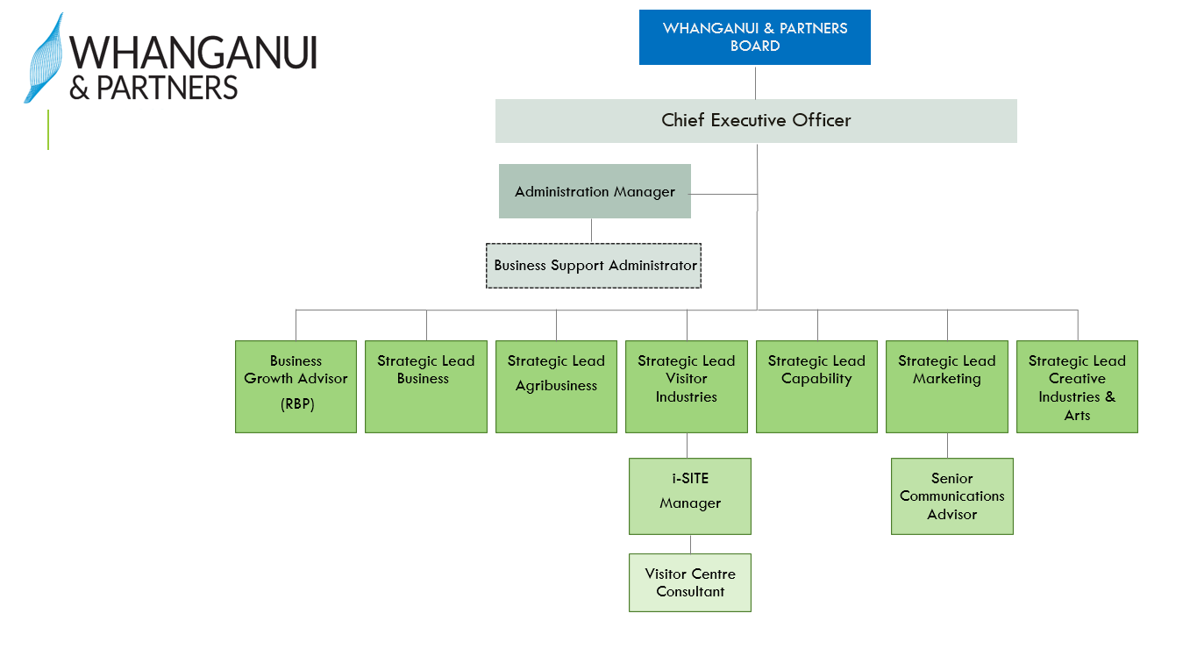
Key Task Summary:

The position of Senior Marketing Executive encompasses the following major functions or Key Result Areas:

- Coordinate W&P's communication activity, inclusive of key channels such as the website, e-newsletters and social media channels relating to both the promotion of Whanganui and the work of Whanganui & Partners
- Provide support in Public Relations (PR), assisting proactive and reactive approaches to PR
- Maintain a detailed knowledge of Whanganui's economic profile, providing outputs to communicate this to the public and stakeholders
- Provide support to the Strategic Lead - Marketing in the development of overall marketing (inclusive of communications) strategy, plans and activities
- Support the Whanganui & Partners team with delivering consistent and professional communications to external stakeholders
- Customer Service
- Risk Management
- Health & Safety
- Long-term & Annual Planning Process
- Emergency Management
- Professional Development and Training
- Other

Key Result Area: | Job holder is successful if:
- Coordinate W&P's communication activity, inclusive of key channels such as the website, e-newsletters and social media channels relating to both the promotion of Whanganui and the work of Whanganui & Partners
- Day-to-day management of website content and maintenance, working with expert web contractors where appropriate  - Day-to-day administration, moderation and engagement of social media accounts, supporting the expansion of engagement with the public (e.g. W&P FB and LinkedIn pages, Discover Whanganui’s FB and IG pages)  - Creation, coordination and delivery of e- newsletters including management and growth of subscriber lists  - Project coordination and content development of key corporate documents such as Statement of Intent and Annual Report  - Management of W&P images including metadata creation and caption writing for searchability, copyright monitoring and organisation, and collation of collections | - Website is updated frequently to ensure information is relevant and motivating to the reader  - Web traffic outcomes are in line with Statement of Intent  - Social media posts are planned across all W&P channels  - Social media outcomes are in line with Statement of Intent  - Whanganui & Partners newsletter is delivered regularly  - Key corporate documents are developed and delivered  - Images and online resources are up-to-date, organised and searchable
- Provide support in Public Relations (PR), assisting proactive and reactive approaches to PR
- Contribute to and support proactive and reactive production of media releases and responses to promote the work of W&P, articulate the health of the economy and contribute to the attractiveness of Whanganui as a destination  - Monitoring of PR presence for both Whanganui and W&P  - Develop and leverage relationships with media outlets and contacts to help amplify our messages  - Maintain awareness of other destination's activity to ensure effective benchmarking  - Maintain knowledge of PR best practice through training and professional development opportunities | - Media mentions of Whanganui & Partners and Whanganui are favourable and in line with Statement of Intent  - Monthly media monitoring reports are developed and maintained  - Media outlets regularly contact W&P for comment on relevant stories  - Promotion of the Whanganui brand is competitive with activity of other destinations  - All PR activities are informed by best practice

- Maintain a detailed knowledge of Whanganui's economic profile, providing outputs to
communicate this to the public and stakeholders

- Produce W&P’s Economic Dashboard monthly with key areas updated to reflect current economic climate  - Provide support to the Strategic Lead - Marketing in the development of overall marketing strategy, plans and activities | - Economic Dashboard and other reporting documents are produced and updated ahead of key stakeholder and public engagements  - W&P’s communications are consistent and effective
- Provide support to the Strategic Lead - Marketing in the development of overall marketing (inclusive of communications) strategy, plans and activities
- Support the SL - Marketing in delivery of marketing campaigns, key projects and other appropriate activities as required  - Provide SL - Marketing with support in the strategic development of all marketing activity | - SL - Marketing is supported in achieving KPls
- Support the Whanganui & Partners team with delivering consistent and professional
communications to external stakeholders
- Provide input into external presentations, ensuring consistency around brand and message  - Development of content for marketing collateral (e.g., visitor guides, investor packs)  - Development of digitisation of existing and new customer processes (e.g. business enquiry process, event application process) | - Appropriate digital tools are used to improve the experience of engaging with Whanganui & Partners  - Required collateral is developed and delivered  - Customer experience with Whanganui & Partners processes is efficient, intuitive and reliable
- Customer Service
- Ensure high-quality internal and external customer service is provided by the marketing function  - Team members are coached and developed to provide excellent customer service  - Monitor and assess customer service delivery | - Customer service-focused behaviour is modelled and reinforced to ensure that internal and external customers are satisfied with the service received  - Team members are able to address, and where possible resolve, customer requests for service  - Customer service standards are achieved  - Regular feedback from key stakeholders is sought and acted upon  - Team members are encouraged to identify better ways of doing things to improve customer service
- Risk Management
- Compliance with Risk Management | - Best practice risk management procedures apply to all projects and activities  - Compliance with risk management policies and procedures  - Risks associated with functions managed/policies being developed are accurately identified, evaluated and reduced
- Health and Safety
- Comply with all safe work procedures, policies and instructions  - Report all incidents, hazards/risks and injuries to supervisors in a timely manner  - Actively participate in the ongoing development of safe workplace practices  - Take personal responsibility for own safety without putting others at risk | - Comply with any reasonable instruction that is given to you by the PCBU or your manager  - Timely, full and accurate completion of incidents on the H&S electronic reporting  - Participate in all Health & Safety programmes and updates as and when required  - Demonstrate commitment to health and safety for yourself and your work colleagues
- Professional Development and Training
- Professional Development/Training Needs | - Own training needs are identified through appraisal and training needs analysis  - Training needs of all staff are identified through appraisal and training needs analysis  - Agreed training programme/development opportunities are taken up  - Knowledge of both management and professional areas remains up-to-date
- Other
- Special projects are completed from time to time, meeting quality standards and deadline requirements

Note:
The above performance standards are provided as a guide only. The precise performance objectives and measures for this position will need further discussion between the jobholder and manager as part of the performance management process.

Work Complexity
- Developing and maintaining relationships with a wide variety of stakeholders
- Balancing the demands of various stakeholders to deliver effective marketing initiatives
- Resolving conflicts
- Liaising with elected members
- Managing staff performance
- Developing strategic, operational and business plans
- Managing budgets
- Preparing reports
Person Specification:

Qualifications and Experience
Essential: | Desirable:
- Understanding of communications, public relations and marketing best practices  - Must possess exceptional writing skills and be able to compose engaging, accurate and original content  - Understanding of copywriting, graphic design, layout, and publishing  - Familiarity with Te Awa Tupua legislation (River Claims Settlement Act 2017) and its principles; Tupua te Kawa  - Ability to think strategically and identify ways to improve communication efforts  - Familiarity with social media platforms and social media marketing, ability to plan content and use programs related to social media planning  - Experience managing digital content  - Demonstrated knowledge and proficiency with communications technologies  - Proficiency with Microsoft Office (Excel, PowerPoint, Word)  - Experience with quantitative research and analysis  - 5-plus years of communications, marketing or public relations or related experience | - Experience working with the media  - Degree in communications, marketing or a related discipline  - Experience working in a local government/multiple stakeholder organisation  - Working knowledge of content management systems, HTML coding, and digital graphics production (e.g. Canva, InDesign)  - Experience with search engine marketing, Google Analytics GA4), and Google AdWords  - Experience with Meta Business Suite and FB Ads Manager

Key Skills/Attributes/Job Specific Competencies
The following levels would typically be expected for the 100% fully effective level:
Core competencies | - Live our values - keeping the organisation's values at the forefront of  decision-making and action  - Improve ways of working - taking action to improve existing conditions and processes; identifying improvement opportunities, generating ideas and implementing solutions  - Focus on customer service - ensuring that the customer and stakeholder perspective is a key consideration behind decision-making and action
Technical competencies | - Communication Skills  Orally communicates ideas, instructions and information that can be clearly understood by others in formal and informal situations. Writes clearly and concisely so that others can easily understand  Effectively and appropriately reduces complex issues to a workable set of fundamentals so that others can understand and take action  - Media  Communicates clearly with media and follows clear signing-off protocols  Employs risk-averse strategies when communicating with media
Working Knowledge | Policy  - Understands and follows Whanganui & Partners policies and procedures and understands how they affect the tasks and responsibilities in one’s job  Computer Aptitude  - Understands operations such as operating systems, common spreadsheets and word processing software. Uses this knowledge to improve one’s ability to perform job duties  Legislation  - Understands relevant laws and regulations and how they affect the tasks and responsibilities in one’s job (e.g. advertising standards, Te Awa Tupua legislation)
Awareness | Health and Safety  - Understands Health and Safety in the Workplace and hazard identification

Variation

From time to time it may be necessary to consider changes in the position description in response to the changing nature of our work environment – including technological requirements or statutory changes. This Position Description may be reviewed as part of the preparation for performance planning for the annual performance cycle or as required.

Acceptance of Position Description:

I have read the attached Position Description and agree that it represents the duties I will perform for the above position.

Employee: Dated:

Manager: Dated:

