**EXECUTIVE ASSISTANT AND ADMINISTRATION MANAGER**

**Position Description**

|  |  |
| --- | --- |
| PD Created / Modified: | October 2023 |
| Department/Group: | Whanganui and Partners |
| Responsible To: | CEO Whanganui and Partners |
| Location: | Innovation Quarter, St Hill Street, Whanganui |
| Position Purpose: | This role is the lynchpin of our operational excellence maintaining and enhancing the essential infrastructure through which the Lead Team can deliver key outcomes to our community. This position exists to:   * Ensure the smooth running of the Whanganui & Partners organisation, with support to and from the Chief Executive and Whanganui & Partners board * Ensure operational excellence across all administrative functions * Enable successful outcomes for the wider team in delivering against the organisational plan * Lead key administrative, planning, compliance, reporting and co-ordination activities for the organisation |

**Whanganui & Partners is Whanganui’s economic development agency**

Our mission is to lead and drive opportunity through business, education, and lifestyle.

We promote Whanganui as a destination to live, visit, work, study and invest. Our activities include supporting new and existing businesses, bringing events to Whanganui and providing the latest economic data, analysis and commentary on the Whanganui district.

***Functional Relationships***

| ***Key Internal and/or external contacts*** | ***Nature of the contact most typical:***  *(e.g. courtesy, understanding others, giving/receiving information, explaining things, liaising, advising, gaining cooperation, facilitating, influencing and persuading, resolving minor conflicts, mediating, negotiating, formal negotiation, supervising, leading.)* |
| --- | --- |
| Internal |  |
| * Whanganui and Partners Board * Whanganui and Partners Team | * Co-operation, courtesy, exchanging of routine information. * Explaining things to people, clarifying and understanding. * Gaining cooperation, advising, resolving minor conflicts. * Motivating, enabling, guiding |
| External |  |
| * WDC democracy team * WDC finance team * Accountants, banks, payroll and invoicing suppliers * IT Suppliers | * Consultation, partnership relationship * Co-operation, courtesy, exchanging of routine information. * Explaining things to people, clarifying and understanding. * Gaining cooperation, advising, resolving minor conflicts. * Facilitating, motivating, persuading. |

***Responsible For:***

|  |  |
| --- | --- |
| Direct Management of Staff: | Business Support Administrator |
| Indirect Management of Staff: | Nil |

***Financial Responsibility:***

|  |  |
| --- | --- |
| Delegated Authority: | In accordance with delegated authority guidelines. |

***Department Structure:***

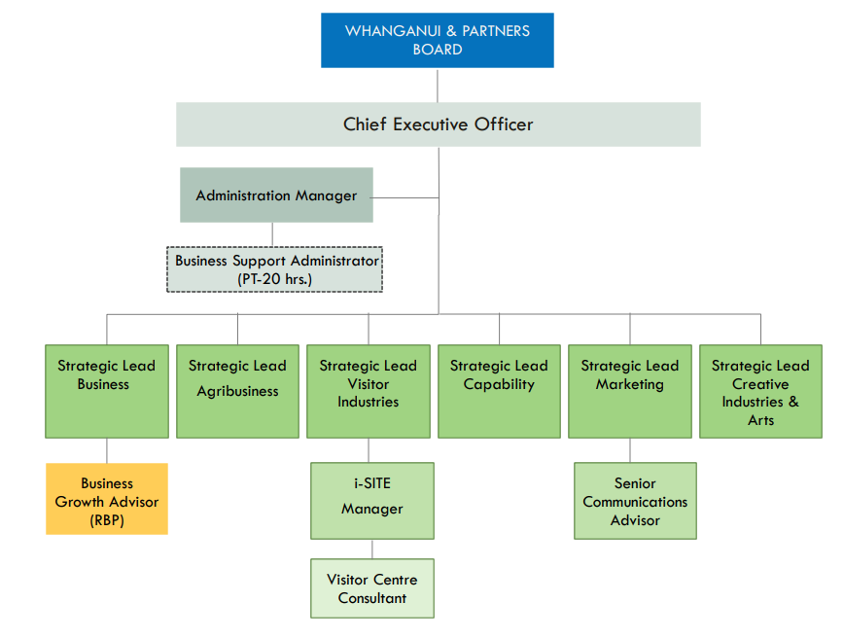

***Key Task Summary:***

The position of **Executive Assistant and Administration Manager** encompasses the following major functions or Key Result Areas:

1. Oversee the financial administration of W&P
2. Day-to-day management of all risk, health and safety, HR, training, ICT & business continuity processes
3. Provides support to the work of the Chief Executive and W&P board
4. Leads the development, implementation and continuous improvement of business processes & systems.
5. Lead the Business Support Administrator
6. Customer Service
7. Risk Management
8. Health & Safety
9. Professional Development and Training
10. Other

|  |  |
| --- | --- |
| ***Key Result Area:*** | ***Job holder is successful if:*** |
| 1. **Oversee the financial administration of W&P** | |
| * Manage the end-to-end payroll process for the organisation, including ensuring we work with appropriate suppliers. * Manage the end-to-end process in processing invoices and other expenses, including ensuring procurement processes and delegated authority are adhered to. * Maintain an overview of financial performance versus budgets to prepare for the Chief Executive and wider organisation. * Act as the day-to-day coordinator between the organisation and its accountant and other financial suppliers (e.g bank, payroll supplier) * Manage financial obligations such as GST filing, annual accounts filing | * Fortnightly pay runs are completed and processed with staff pay in their bank accounts, correct and on time. * Purchase orders provided are authorised, including an accurate General Ledger code. * Invoices are accurately coded to the correct General Ledger account, authorised and forwarded for payment in a timely manner. * Invoices and claims for are generated in an accurate and timely manner to ensure money is received promptly. * Expenditure recorded and coded correctly. * Reports available. * IRD Returns are completed and submitted on time and are accurate. |

|  |  |
| --- | --- |
| 1. **Day-to-day management of all risk, health and safety, HR, training, ICT & business continuity processes** | |
| * Manage third party contractors/suppliers involved in helping to deliver administrative processes * Ensure appropriate records/registers and processes are maintained * Maintain associated policies and prepares reports for Chief Executive and Board * Coordinate the health and safety committee and ensuring processes are adhered to * Manage the smooth-running of our facilities, including being the contact for all matters relating to the buildings/leases * Maintain insurance requirements   Maintains the organisation intranet | * Administration tasks are completed to high quality standard. * Internal and external customers are satisfied with their interaction and service provided. * Ensuring that the building, policies and processes are all up to date. Health and safety policy requirements are met. * Office systems run smoothly with a continuous improvement approach. |

|  |  |
| --- | --- |
| 1. **Provides support to the work of the Chief Executive and W&P board** | |
| * Act as the board secretariat, preparing all board meeting times, venues and agendas * Attend board meeting, compiling board minutes * Management of the BoardPro function, compiling and publishing all meeting papers * Coordinate with the Chief Executive on internal reporting requirements for board and Council meetings * Liaise with WDC democracy team around council reporting requirements * Coordinate W&P team meetings * Provide advice to the Chief Executive as required | * Agendas are prepared in a timely manner, all meetings are set up as required and accurate minutes are recorded and maintained where necessary * Board Papers published on time. * Meetings and functions are well organised and run smoothly. * Incoming and outgoing correspondence is managed in an efficient and timely manner. * Be up-to-date on all matters the CEO is involved in to be able to confidently advise and respond to team members’ queries as appropriate. Advice is timely, accurate and appropriate. Zero breaches of confidentiality. |
| 1. **Leads the development, implementation and continuous improvement of business processes & systems** | |
| * Recommend and implement improvements to our business processes, policies and systems with a particular emphasis on:   + Business planning   + Budgeting   + Financial control   + Reporting   + Project control (delivery of contracts) | * Office systems run smoothly to the satisfaction of the CEO and are improved upon when necessary. * CEO is supported with Business Planning and Budgeting processes. * Reports prepared in a timely manner. * Prepare funding applications, and business cases, keeping accurate and detailed records throughout the process, providing reports as required. Project plans developed and maintained. Act as project manager for specified projects. |
| 1. **Lead the Business Support Administrator** | |
| * Manage the performance and support the development of the Business Support Administrator * Delegate tasks/responsibilities to ensure administrative resource is utilised appropriately. | * Administration tasks are completed to high quality standard. * Accounts Payable and Accounts Receivable tasks are performed in a timely manner. |
| 1. **Customer Service** | |
| * Ensure high quality internal and external customer service is provided by marketing function * Team members are coached and developed in providing excellent customer service. * Monitor and assess customer service delivery**.** | * Customer service focussed behaviour is modelled and reinforced to ensure that internal and external customers are satisfied with the service received. * Team members are able to address, and where possible resolve, customer requests for service. * Customer service standards are achieved. * Regular feedback from key stakeholders is sought and acted upon. * Team members are encouraged to identify better ways of doing things to improve customer service. |
| 1. **Risk Management** | |
| * Compliance with Risk Management. | * Best practice risk management procedures apply to all projects and activities. * Compliance with risk management policies and procedures. * Risks associated with functions managed/policies being developed are accurately identified, evaluated and reduced. |
| 1. **Health and Safety** | |
| * Comply with all safe work procedures, policies and instructions. * Report all incidents, hazards/risks and injuries to supervisors in a timely manner. * Actively participate in the ongoing development of safe workplace practices * Take personal responsibility for own safety without putting others at risk. | * Comply with any reasonable instruction that is given to you by the PCBU or your Manager. * Timely, full and accurate completion of incidents on the H & S electronic reporting. * Participate in all Health & Safety programmes and updates as and when required. * Demonstrate commitment to Health & Safety for yourself and your work colleagues. |
| 1. **Professional Development and Training** | |
| * Professional Development/Training Needs. | * Own training needs are identified through appraisal and training needs analysis. * Training needs of all staff are identified through appraisal and training needs analysis. * Agreed training programmed/development opportunities are taken up. * Knowledge of both management and professional areas remains up to date. |
| 1. **Other** | |
| * Special projects are completed from time to time, meeting quality standards and deadline requirements. | |

***Note:***

*The above performance standards are provided as a guide only. The precise performance objectives and measures for this position will need further discussion between the jobholder and manager as part of the performance management process.*

| **Work Complexity** | |
| --- | --- |
| * Judgement needed to prioritise time and a range of varied work priorities. * Managing a number of tasks/jobs at the same time and ensuring that all deadlines are met. * Explaining processes and procedures and encouraging people to follow them. * Maintain project plans and knowledge of digital, economic development, visit, innovation and education projects and processes. * Needs to be highly organised and methodical. * Business case, investment memorandum and report writing. * Project Management. * Dealing professionally with difficult people, listening to their concerns, trying to help resolve where possible, taking ownership of the need to provide a solution. (professional relationship management) * Managing many tasks/jobs at the same time and ensuring that all deadlines are met. * Ability to manage team and stakeholder expectations and priorities across multiple work streams. * Clarifying and organising tasks to best assist the needs of the manager and the Council. * Understanding the differences and working within a Government organisation. * Political nous and commercially savvy to identify relationship and project risks. * Professional and discrete when dealing with visitors and commercial information. | |
| ***Person Specification:*** |

|  |  |
| --- | --- |
| ***Qualifications*** | |
| Essential: | Desirable: |
| * A current NZ Driver’s Licence | * Appropriate tertiary qualification |
| ***Knowledge/Experience*** | |
| Essential: | Desirable: |
| **It is expected that, with limited supervision, the candidate will be able to deliver each of the key objectives of the role. It is therefore expected that they will have:** | |
| * Proficient with payroll and accounting systems (e.g. Xero, i-Payroll) * Deep understanding of the administrative requirements/processes of a well-run organisation * Deep understanding of the value of Whanganui & Partners to the community * Proven deliverer of results * Strong IT and computer skills (e.g. MS Office). | * Proficient in liaising with senior management/board level communication/processes * Knowledge of HR, health & safety and risk management regulations * Training in employment law, budgeting, finance, accounting * Line management experience * Office management experience * Deep understanding of the administrative requirements of a local government agency |

| ***Key Skills/Attributes/Job Specific Competencies***  *The following levels would typically be expected for the 100% fully effective level:* | |
| --- | --- |
| **Expert** | * **Reliability and responsibility –** responsible and resourceful, takes ownership of our administrative function and ensures processes are fit for purpose * **Planning and organisational skills –** pragmatic and well-organised, strong at time-management as an individual and in the context of the wider team’s delivery * **People management –** a great communicator who enjoys working as part of a multi-dimensional team in the context of delivering to the requirements of the organisation * **Process Improvement** – has the ability to recognise where enhancements can be made and able to deliver upon them * **Reporting skills –** an eye for detail and accuracy * **Teamwork –** enjoys an environment of assisting others to enable their own personal achievements   **Policy -** Understands and follows policies and procedures and how they affect the tasks and responsibilities in one’s job. |
| **Advanced** | * **Political awareness –** understands the workings of local government, recognising the boundaries between governance and management and acts accordingly. * **Project management –** planning and overseeing the achievement of a goal or objective within a certain timeframe, monitors and troubleshoots to ensure achievement. * **Health and Safety** - Understands Health and Safety in the Workplace and hazard identification |
| **Working Knowledge** | * **Computer Aptitude -** Understands operations such as operating systems, common spreadsheets and word processing software. Uses this knowledge to improve one’s ability to perform job duties. * **Legislation -** Understands relevant laws and regulations and how they affect the tasks and responsibilities in one’s job (e.g. advertising standards) |
| **Personal Attributes** | **Attitude**   * Positive and enthusiastic attitude with a high level of self-motivation and initiative applied to all tasks   **Customer focus**   * Strong customer service focus, passion and pursuit of excellence.   **Adaptability**   * Ability to learn quickly and retain new information. * Ability to work under pressure and prioritise workload. |

***Variation***

From time to time it may be necessary to consider changes in the position description in response to the changing nature of our work environment – including technological requirements or statutory changes. This Position Description may be reviewed as part of the preparation for performance planning for the annual performance cycle or as required.

***Acceptance of Position Description:***

I have read the attached Position Description and agree that it represents the duties I will perform for the above position.

Employee: Dated:

Manager: Dated: